Data Structure and Algorithm
Laboratory Activity No. 11

Implementation of Graphs

Submitted by: | Instructor:
Balana, Jerkielle Roen O. | Engr. Maria Rizette H. Sayo

October 18, 2025

Objectives
Introduction
A graph is a visual representation of a collection of things where some object pairs are linked together. Vertices are the points used to depict the interconnected items, while edges are the connections between them. In this course, we go into great detail on the many words and functions related to graphs.
An undirected graph, or simply a graph, is a set of points with lines connecting some of the points. The points are called nodes or vertices, and the lines are called edges.

A graph can be easily presented using the python dictionary data types. We represent the vertices as the keys of the dictionary and the connection between the vertices also called edges as the values in the dictionary.
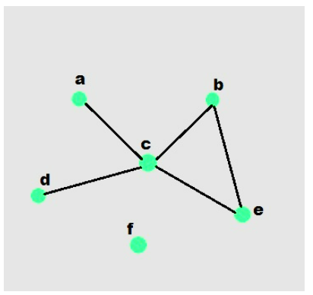

Figure 1. Sample graph with vertices and edges

This laboratory activity aims to implement the principles and techniques in:
- To introduce the Non-linear data structure – Graphs
- To implement graphs using Python programming language
- To apply the concepts of Breadth First Search and Depth First Search

Methods
  - Copy and run the Python source codes.
  - If there is an algorithm error/s, debug the source codes.
  - Save these source codes to your GitHub.

from collections import deque

class Graph:
def __init__(self):
self.graph = {}

def add_edge(self, u, v):
"""Add an edge between u and v"""
if u not in self.graph:
self.graph[u] = []
if v not in self.graph:
self.graph[v] = []

self.graph[u].append(v)
self.graph[v].append(u) # For undirected graph

def bfs(self, start):
"""Breadth-First Search traversal"""
visited = set()
queue = deque([start])
result = []

while queue:
vertex = queue.popleft()
if vertex not in visited:
visited.add(vertex)
result.append(vertex)
# Add all unvisited neighbors
for neighbor in self.graph.get(vertex, []):
if neighbor not in visited:
queue.append(neighbor)
return result

def dfs(self, start):
"""Depth-First Search traversal"""
visited = set()
result = []

def dfs_util(vertex):
visited.add(vertex)
result.append(vertex)
for neighbor in self.graph.get(vertex, []):
if neighbor not in visited:
dfs_util(neighbor)

dfs_util(start)
return result

def display(self):
"""Display the graph"""
for vertex in self.graph:
print(f"{vertex}: {self.graph[vertex]}")

# Example usage
if __name__ == "__main__":
# Create a graph
g = Graph()

# Add edges
g.add_edge(0, 1)
g.add_edge(0, 2)
g.add_edge(1, 2)
g.add_edge(2, 3)
g.add_edge(3, 4)

# Display the graph
print("Graph structure:")
g.display()

# Traversal examples
print(f"\nBFS starting from 0: {g.bfs(0)}")
print(f"DFS starting from 0: {g.dfs(0)}")

# Add more edges and show
g.add_edge(4, 5)
g.add_edge(1, 4)

print(f"\nAfter adding more edges:")
print(f"BFS starting from 0: {g.bfs(0)}")
print(f"DFS starting from 0: {g.dfs(0)}")

Questions:
    - What will be the output of the following codes?
    - Explain the key differences between the BFS and DFS implementations in the provided graph code. Discuss their data structures, traversal patterns, and time complexity. How does the recursive nature of DFS contrast with the iterative approach of BFS, and what are the potential advantages and disadvantages of each implementation strategy?
    - The provided graph implementation uses an adjacency list representation with a dictionary. Compare this approach with alternative representations like adjacency matrices or edge lists.
    - The graph in the code is implemented as undirected. Analyze the implications of this design choice on the add_edge method and the overall graph structure. How would you modify the code to support directed graphs? Discuss the changes needed in edge addition, traversal algorithms, and how these modifications would affect the graph's behavior and use cases.
    - Choose two real-world problems that can be modeled using graphs and explain how you would use the provided graph implementation to solve them. What extensions or modifications would be necessary to make the code suitable for these applications? Discuss how the BFS and DFS algorithms would be particularly useful in solving these problems and what additional algorithms you might need to implement.

Results

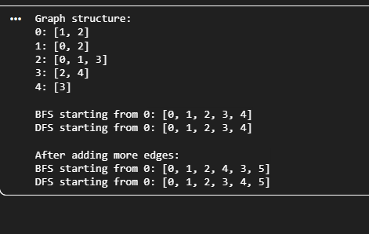
    - DFS uses recursion for exploring nodes deeply, while BFS systematically visits nodes level by level using a queue.
    - The adjacency list (used in this code) is the most efficient representation for sparse graphs and is widely used in practical implementations.
    - In an undirected graph, each connection is bidirectional—meaning if vertex A is connected to vertex B, then B is also connected to A.
This is why in the add_edge method, both self.graph[u].append(v) and self.graph[v].append(u) are called.
• BFS can find the shortest route in unweighted maps (like grid-based city layouts).
• For realistic navigation, add weights (distance or time) and use Dijkstra’s or A* algorithms.

Conclusion

The conclusion expresses the summary of the whole laboratory report as perceived by the authors of the report.
In this laboratory activity, we successfully implemented and explored the fundamental concepts of graph data structures using Python. By applying Breadth-First Search (BFS) and Depth-First Search (DFS) traversals, we demonstrated two core algorithms for navigating and analyzing graph-based relationships. Through this exercise, we learned the practical differences between recursive and iterative traversal methods and gained insight into how graph representations like adjacency lists, matrices, and edge lists impact performance and memory efficiency.
Graphs are powerful tools for modeling complex, real-world systems such as social networks, transportation routes, and communication pathways. The experiment also highlighted the flexibility of Python in implementing and extending graph structures for both undirected and directed models. Overall, this activity strengthened our understanding of non-linear data structures, traversal algorithms, and their wide range of applications in computer engineering and data science.

References
[1] Co Arthur O.. “University of Caloocan City Computer Engineering Department Honor Code,” UCC-CpE Departmental Policies, 2020.

